### Who We Are

West Shore Composite (WSC) is a youth mountain bike team focused on character and athletic development for 6-12 grade students. We welcome athletes from Mechanicsburg, West Shore, Northern, Camp Hill, and Cumberland Valley districts, as well as all private, charter, cyber, and homeschools. With a vision to “get more kids on bikes” and develop a lifelong love of the outdoors, we support a wide array of students, from those who have never ridden a bike through nationally ranked racers…no one sits on the bench - we all ride!

Our athletes are led by trained volunteer coaches who develop practice environments to meet the needs of riders of all abilities. They strive to deliver positive feedback so all students feel good about the progress they are making, no matter how advanced or new they are to the sport. It is our goal to make a lasting impact by helping athletes build fitness, confidence, friendships, leadership, and character all while riding Pennsylvania’s amazing trails.

WSC offers many opportunities for personal growth, and athletes are encouraged to participate in community trail maintenance and development. Teams have provided thousands of hours in trail stewardship across Pennsylvania, affording a unique community service recognized by many colleges and schools while developing athletes’ pride and self-esteem.

### How You Can Help

We are organized under the National Interscholastic Cycling Association (NICA). NICA provides professional training, vets coaches rigorously, insures our activities, and organizes races. Both athletes and the team pay dues to NICA, and even though this is a “scholastic program”, WSC does not receive any funding from school districts. To support our mission, we seek donations and sponsorships to help purchase race jerseys, equipment, and further coach training and certifications such as Wilderness First Aid, CPR, and skills courses. WSC also hopes to raise enough money to help support students and families that may not otherwise be able to participate due to lack of funds, safety equipment or even a bike.

WSC is registered as a non-profit 501(c)3 (Action Sports Project, 2295 Earth Rd, Enola Pa 17025) and can accept contributions in support of the team.

We appreciate your consideration and hope you will join other community leaders in getting more kids on bikes!

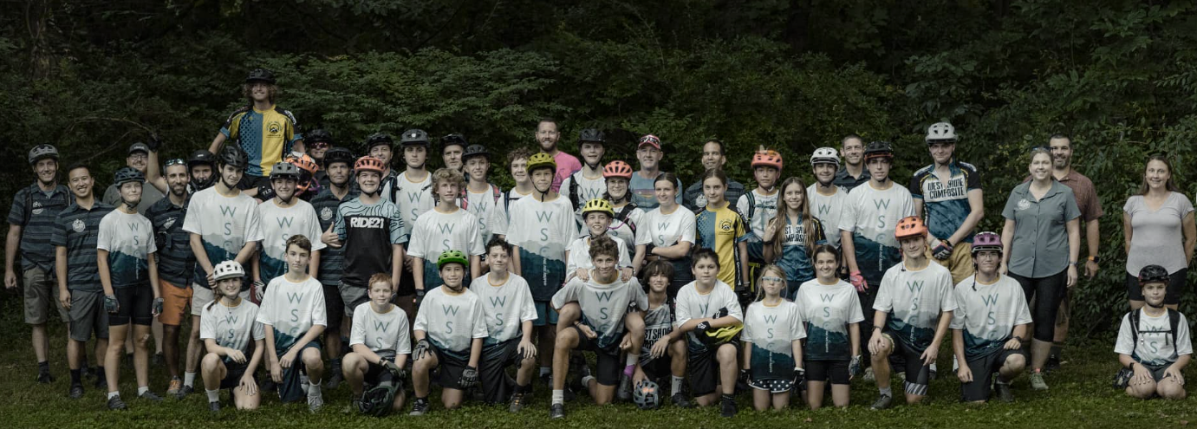

### Partnering With Us

Athletes already pay a significant fee to join the team and must provide their own bike and equipment. To welcome as many students as possible, regardless of financial situation, we need help purchasing race jerseys, team supplies, reducing the cost of advanced coach training (such as Wilderness First Aid, CPR, and skills instruction courses), and helping families in need.

We offer the following sponsorship opportunities for businesses and community organizations:

**Exclusive Title Sponsor: $3,500 (Only One Available)**

* Top Banner logo on WSC Team Training Shirt
* Large logo on WSC Team Pit Station (tent wall/table runner)
* Large logo on WSC Team Trailer
* Recognition in team communications and Social Media pages

**Diamond Sponsor: $2,000 (Two Available)**

* Medium logo on WSC Team Training Shirt
* Medium logo on WSC Team Pit Station (tent wall/table runner)
* Standard logo on WSC Team Trailer
* Recognition in team communications and Social Media pages

**Gold Sponsor: $1,000 (Three Available)**

* Standard logo on WSC Team Training Shirt
* Standard logo on WSC Team Pit Station (tent wall/table runner)
* Standard logo on WSC Team Trailer
* Recognition in team communications and Social Media pages

**Silver Sponsor: $500 (Five Available)**

* Standard logo on WSC Team Pit Station (tent wall/table runner)
* Standard logo on WSC Team Trailer
* Recognition in team communications and Social Media pages

**Bronze Sponsor: $250**

* Recognition in team communications and Social Media pages

**All Other Donation Levels are Welcome and Appreciated!**

**Interested in being a Sponsor or Donating to Support the Team?**



<https://www.westshorecomposite.com/>

### Where Your Support Will Shine

